Ultrastructural analysis of neurons in a temporal integrator for eye movements

Ashwin Vishwanathan, Kayvon Daie, Alexandro D. Ramirez,

Jeff W Lichtman, Emre Aksay, and H. Sebastian Seung

Neuroscience Institute and Computer Science Department

Princeton University, Princeton, NJ 08544

Institute for Computational Biomedicine and

Department of Physiology and Biophysics,

Weill Cornell Medical College, New York, NY 10021

Department of Molecular and Cellular Biology and Center for Brain Science,

Harvard University, Cambridge, MA 02138

**Abstract**

Neural integrators are involved in a variety of sensorimotor and cognitive behaviors. The oculomotor system contains a simple example, a hindbrain neural circuit that takes velocity signals as inputs, and temporally integrates them to control eye position. We combined observations of behavior, physiology, and anatomy to study integrator neurons. Two-photon calcium imaging of the larval zebrafish hindbrain was performed while simultaneously monitoring spontaneous eye movements. Integrator neurons were identified as those neurons with activities highly correlated with eye position, and the same neurons were then reconstructed from serial electron microscopic images. Three morphological classes of neurons were observed: an ipsilaterally projecting neurons located medially, a contralaterally projecting neurons located more laterally, and a population at the extreme lateral edge of the hindbrain for which we were not able to identify axons. Based on their somatic locations, we infer that neurons with only ipsilaterally projecting axons are glutamatergic, whereas neurons with only contralaterally projecting axons are GABAergic. Dendritic and synaptic organization of the ipsilaterally projecting neurons suggest a broad sampling from inputs on the ipsilateral side. We also observe the first conclusive evidence of synapses between integrator neurons, which have long been hypothesized by recurrent network models of integration via positive feedback.

## 1 Introduction

Combining two-photon calcium imaging with serial electron microscopy (EM) is an emerging approach for studying the structure and function of neural circuits at cellular resolution. In the mouse retina (Briggman:2011ct) and primary visual cortex (Bock:2011fk; Lee:2016ti), this approach has been used to study the structure and function of visual neurons. Here we apply this approach to a population of neurons defined by their encoding of behavioral variables, rather than stimulus variables. Namely, we focus on neurons that carry eye position signals that are located in a hindbrain neural circuit known as the "velocity-to-position neural integrator," or "neural integrator" for short (Major:2004dk; Joshua:2015kx). Our study is done in the larval zebrafish, which has emerged as an important model organism for investigating the relation between neural circuits and behavior (Friedrich:2010hj).

The neural integrator gets its name because the transformation of eye velocity into eye position is the computational operation of integration with respect to time. Integrator neurons are operationally defined as premotor neurons that carry a horizontal eye position signal in their spiking (there is also an integrator for vertical eye movements, but it will not be discussed here) . Integrator neurons are thought to send their eye position signals to extraocular motor neurons through monosynaptic and polysynaptic pathways. They are also thought to receive inputs from multiple convergent pathways that encode eye velocity for every type of eye movement. Therefore, the neural integrator is the “final common pathway” for all types of eye movements in fish (Pastor:1994tx; Aksay:2000cn; Aksay:2001fx), rodents (vanAlphen:2001vc), non-human primates (Robinson:1989wt; Robinson:1975vm), and humans (Leigh:2015ts).

Previous attempts to understand how the integrator neurons transforms the ’pulse’-like eye velocity signals to a ’step’-like eye position output have relied on combining single-neuron electrophysiology with light-microscopic dye fills. Intracellular recordings in goldfish hindbrain neurons that exhibited spiking correlated to eye position, followed by anatomical dye fills, show the axons of these neurons to send collaterals to areas where other integrator neurons were observed (Aksay:2000cn). Similar anatomical observations have been observed in cats (McCrea:1985hx) and nonhuman primates (Steiger:1979ev). These observations have shaped theoretical models to propose that integration can be setup by recurrent excitation between these neurons (Kamath:1976jm; seung\s\do5(h)ow\s\do5(1)996; Seung:2000kl; fisher\s\do5(m)odeling\s\do5(2)013; goncalves\s\do5(o)ptogenetic\s\do5(2)014). More recent imaging methods have relied on two-photon calcium imaging to identify many integrator neurons followed by sparse, targeted single neuron electroporation of fluorescent indicators for anatomical reconstruction (Lee:2015dv). While these studies have delineated the arborization and projection patterns of integrator neurons, they were limited to one or a few neurons in any individual brain and do not reveal locations and the distributions of their input and output synapses. And although the axonal projections could potentially synapse onto dendrites of other integrator neurons, conclusive evidence has been lacking.

We combined two-photon calcium imaging in a behaving fish to identify neurons in the neural integrator. We then reconstructed the same neurons using serial electron microscopy. We found evidence for multiple classes of neurons within the integrator population based on differences in dendritic arborization, axonal projections and synaptic distributions. These include neurons with ipsilaterally projecting axons at medial locations that are inferred to be excitatory, and neurons with contralaterally projecting axons at more lateral locations that are inferred to be inhibitory. In addition, we found neurons at the lateral most edge of the volume, for which we could not identify an axon, and a small subset of previously unreported integrator neurons with both ipsilateral and contralateral axonal projections. We identified all chemical synapses in our images by the existence of presynaptic vesicles and postsynaptic densities. Chemical synapses involving integrator neurons contained small vesicles, suggesting the presence of conventional rather than peptidergic neurotransmitters. Finally we report evidence for direct synaptic connectivity between integrator neurons.

## 2 Results

### 2.1 Combined two-photon and electron microscopy of integrator neurons

To identify putative integrator neurons we performed two-photon calcium imaging of the caudal hindbrain in a x dpf larval zebrafish following bolus loading of the calcium sensor Oregon Green BAPTA 1-AM. [describe imaging plane specs here, focused on left side where loading was best]. Calcium signals were correlated with eye position to identify integrator somata from the imaged planes (Fig. 1A) (Miri:2011ft). Neurons were identified as integrator neurons if saccade-triggered average fluorescence was correlated strongly with saccade-triggered eye position following an ipsiversive saccade (Fig. 1A,b, arrow) (Pearson coefficient >0.6) (Fig. 1A,b). This resulted in the identification of 22 integrator neurons from 3 distinct imaging planes.

Following functional identification of neural integrator neurons, the tissue was fixed, stained, sectioned for serial electron microscopy and imaged at a final resolution of 5545 nm (RC, ML, DV) . These images were montaged and aligned to create a 3D electron microscopy volume (EM) (Fig. 1B and Methods). The resulting EM volume extended ventrally from the Mauthner cell axon plane by 60*m*, caudally from the border of rhombomere 5/6 by 200*m* and laterally from the midline by 100*m*. The LM and EM volumes were registered to each other by an affine transform, producing correspondence of labeled neurons and blood vessels (Fig. 1C, Methods). The soma of all 22 integrator neurons from the LM volume were located in the EM volume within the rhombomeres 6,7 and 8 (Fig 1D, colored by time constants).

### 2.2 Stripe shaped patterning of somata in the hindbrain

Cell bodies in the hindbrain of the larval zebrafish follow a stereotypic stripe like pattern of alternating cell bodies and neuropil. Cells within the same stripe typically share the same neurotransmitter identity, and morphology (Higashijima:2004cn; Kinkhabwala:2011et; Koyama:2011kl). To extract this stripe like organization, we projected the locations of all cell somata (Fig. 1D, ’o’ symbol) from the high-resolution imaged area onto a single plane. The high-res EM volume contained a total of 2967 somata spread over rhombomeres 5 through 8 (Fig. 1D). The volume also contained well-known landmarks like the Mauthner neuron (Lee:1993ip), the axon of the contralateral Mauthner neuron, neurons MiD2 and MiD3 of the reticulo-spinal network (Lee:1993ip), and a number of commissural bundles (Fig. 1D). This revealed an alternating pattern of cell somata and neuropil. We were able to locate 3 peaks of cell somata, excluding a peak that corresponds to neurons at the midline, each corresponding to a likely stripe (Fig. 1D, bottom panel, S1-3). The three stripes were labeled based on their proximity to the midline, as medial (S1), intermediate (S2) and lateral stripe (S3) respectively. The medial stripe S1 aligns with a group of neurons that express the *alx* transcription factor and are most often glutamatergic (Kimura:2006hd). Previous work has shown that the large majority of glumatergic integrator neurons reside in this stripe (Lee:2015dv). The intermediate peak corresponds to neurons known to express the transcription factor *dbx1b* (Kinkhabwala:2011et)*.* The majority of integrator neurons in this peak express GABA, while a small minority express glutamate. At the ventral locations explored here, integrator neurons in this stripe are almost exclusively GABAergic (Lee:2015dv). The lateral most peak of neurons corresponds with the expression of the *barhl* transcription factor, which is also thought to be glutamatergic (colombo\s\do5(z)ebrafish\s\do5(2)006; Kinkhabwala:2011et).

### 2.3 Anatomical properties of integrator neurons

After the identification of the integrator neurons in the EM volume, we reconstructed all 22 integrator neurons and annotated the pre- and postsynaptic locations for these neurons. We first characterized some of the anatomical properties that were common to all integrator neurons.

#### Somata

The somatic locations of the 22 integrator neurons were distributed over ~23 µm in the dorsoventral axis and along the entire rostrocaudal extent of the imaged volume. A subset of these neurons was located very close to the midline and at the rostral edge of the imaged volume, very close to the border of rhombomeres 6,7 and at the caudal end of the imaged volume, located in rhombomere 8, roughly between myotomes 1,2. Another subset of neurons was located at the lateral end of the volume in rhombomere 8. The diameters of the integrator neurons were normally distributed, with a mean of 4.50.6:*m* (mean ± standard deviation). In general, the size of the somata was proportional to the persistence level of the neurons, with larger neurons exhibiting higher degree of persistence (Sup. Fig. 1B). On average 3.31.5 neurites emerged from the somata, and traveled ventrally.

#### Synapses

We annotated 406 presynaptic (green circles, Fig. 2) and 2229 postsynaptic sites (red circles, Fig. 2) on the 22 integrator neurons. Synapses were identified by the presence of a presynaptic vesicle pool and an opposing postsynaptic density. Synapses from or onto integrator neurons contained small vesicles, presumably containing a conventional neurotransmitter. Elsewhere in the volume we did identify synapses with dense core vesicles, presumably containing a peptide neurotransmitter (Sup. Fig. 2A).

• Integrator presynaptic sites

The presynaptic site was generally at a varicosity in the axon with vesicles throughout. Opposing the postsynaptic density, a small, denser cluster of vesicles was typically observed, along with the presynaptic density. These features are consistent with the idea of a presynaptic active zone. The number of presynaptic sites on a neuron averaged 5844.39. This is an underestimate of the number of output synapses from an integrator neuron, because most axonal arbors were cut off by the borders of the volume. If statistics are restricted to the 3 neurons that were more complete than others, there were 15647.46 postsynaptic sites.

• Integrator postsynaptic sites

The postsynaptic densities were observed as a darkening of the membrane, indicative of more electron dense regions, corresponding to more protein density. The number of postsynaptic sites on a neuron averaged 10174. This is a reasonable estimate of the number of input synapses to an integrator neuron, because most dendritic arbors were reconstructed in their entirety. If statistics are restricted to the 3 neurons that were more complete than others, there were 9738 presynaptic sites.

• Cell Junctions

Along the somatic membrane, a darkening of the membrane interrupted by small gaps was often observed (Sup. Fig. 2B). The darkening persisted over multiple serial sections, suggesting that it was not an artifact of tissue preparation or imaging. These darkenings were visible between somata of integrator-integrator and integrator-non-integrator neurons. We speculate that these darkenings are some kind of cell junction. Gap junctions are known to exist in the developing larval zebrafish hindbrain (Jabeen:2013fm).

#### Dendrites

Dendrites were defined by the absence of presynaptic vesicles and the presence of postsynaptic densities. They were mostly oriented ventral to the location of the somata. Dendrites were smooth rather than spiny. Some dendrites exited the imaged volume, leading to incompletely reconstructed neurons, where as for neurons with small dendritic arbors were completely reconstructed and did not have any dendrites that exited the imaged volume.

#### Axons

We defined axons as neurites with presynaptic vesicles. No axons were observed emerging directly from the somata. Instead, dendrites bearing postsynaptic sites turned into axons with presynaptic sites. This region of transition, form dendrite to axon, we termed axon initiation site. Example axon initiation sites are indicated in Fig. 2, showing the dendrite (neurite with red postsynaptic sites) turning into axons at the axon initiation (open arrow) . The main trunk of the axon extended rostrally and ventrally (Fig. 2 A,B,C). From the main trunk emerged mediolateral branches, which we will term collaterals. Those at the rostral extreme of the volume appeared to overlap with the expected location of the abducens motor nucleus (based on its known position within rhombomere r5,6 ).

We observed sheaths around some axonal segments. In some locations, we saw that the sheath wrapped around the axon a few times, loosely enough that cytoplasmic space was visible (Fig. 2A, EM panel). This was consistent with the definition of loose myelin (Caley:1974fk). This is different from the more conventionally observed compact myelin which appears as dark as seen elsewhere in the volume. The axon of the neuron in Fig. 2A was intermittently loosely myelinated along its rostrocaudal section. Mediolateral collaterals emerged from the gaps in loose myelin, and remained unmyelinated. Such loose myelin sheaths have been previously reported in goldfish (Rosenbluth:1961gl).

In 10/22 (45%) integrator neurons the presence of a contralaterally projecting axons was identified. Because neurites in the contralateral hindbrain were not reconstructed, we relied on several other features for axon determination. First the putative axons were devoid of any postsynaptic sites on the ipsilateral side (Fig. 2D soma to axon initiation site, open arrow). The lack of postsynaptic sites on these putative axons is similar to the initial segment of conventional axons that were identified by the presence of vesicles, where no presynaptic terminals in the proximal part of the axon were observed, and presynaptic sites emerged only distally (Fig. 2B, initial segment of axon). Secondly, before crossing the midline, the putative axon became engulfed by processes that appeared glial in nature (Fig. 2 C,D, EM inset G). The glial engulfment is consistent with the idea of ‘glial bridges‘ that are instrumental in the guidance of axons during development (Barresi:2005iw). Thirdly, these putative axons were thinner than the remaining neurites of the neuron. The diameter of these putative axons were smaller to the other neurites and were similar to the diameters of conventional axons (Sup. Fig. 1C). The mean axonal diameter was less than the mean dendrite diameter, conforming to the textbook notion that axons are thinner than dendrites. These features were applied to determine a neurite to be a putative axon.

Application of this procedure revealed that putative axons emerged either from the somata or from a primary neurite from the somata of the integrator neuron (4/4 Somata to primary neurite). Putative axons also contained a few postsynaptic sites (Fig. 2D), before the axon initiation site.

#### Small protuberances

A small fraction (3% or 89/2229) of the postsynaptic sites were located on finger-like projections from dendrites that were enveloped by invaginations of axonal boutons (Fig. 2B, EM panel 2). These projections resemble structures found across multiple species called *spinules*, and are thought to be present on large, active synapses (Petralia:2015ge)

We also observed a primary cilia on all 22 integrator neurons that were reconstructed. Primary cilium are know to be present in most, if not all mammalian cells, including neurons, and are though to be important for normal development (Han:2010kl; Lee:2010fy). This cilium, typically <1 m, is enriched with microtubules, and emerges from the neuron somata very close to the Golgi complex. In some cases, this primary cilium terminated inside processes that resembled glial like structures (Sup. Fig. 3A). Orientation of primary cilium in integrator neurons did not show any orientation preference (Sup. Fig. 4B)

### 2.4 Axonal projection patterns of integrator neurons

The reconstructed integrator neurons were then divided into four groups based on the spatial projection patterns of the axons that were identified. Below we have detailed the properties of integrator neurons from each of these four groups.

*Ipsilateral projection only (“ipsi-only”)* - Six neurons located at the rostral edge of the volume, were observed to have only ipsilaterally projecting axons (Fig. 3A). Two representatives are shown in Figs. 2A and B. The axons were clearly identified by the presence of *en passant* boutons with presynaptic vesicles. The somata were located at the rostral extent of the volume close to the midline (Fig. 3A, Ipsi. only). The axons were oriented along the rostro-caudal (RC) axis with the rostral end more ventral as compared to the caudal end. The average length of axons was 270*m* (Sup. Table) with the longest reconstructed axon being 683 µm. The rostral edge of the imaged volume is approximately the site of the abducens motor nuclei . We noticed that two of the six axons had projections had terminations near the abducens (Sup. Fig) . The axon initiation site was on average located 36*m* from the somata.

Neurons in this group had large dendritic arbors, with the dendrites arborizing over 13.3% of the total imaged volume (Sup. Fig. 4A,B,C). The dendrites emerged laterally from somata and always extended ventrally. Only in one case the dendrites were observed to cross the midline, as indicated by the presence of postsynaptic sites (Fig. 3A, Ipsi. only, arrowhead). The average diameter of dendrites was significantly larger as compared to the diameter of the axons (Fig. 3B, , ttest).

*Both ipsi- and contralateral projections (“ipsi-contra”)* - Two neurons had axons with both ipsilateral and contralateral projections (Fig. 2C, 3A, ipsi-contra). Integrator neurons from this group were located more lateral to the neurons from *ipsi-only group.* The ipsilaterally projecting axons resembled the axons of the ipsi-only group of neurons (Fig. 3A), with similar tilt in the rostro-caudal axis. Both neurons contained another neurite crossed the midline. We infer that this neurite is a putative contralaterally projecting axon. This cannot be confirmed with certainty, because its presynaptic sites are on the contralateral side of the hindbrain, outside the imaged volume. Our inference is based on a number of cues as mentioned previously. In both cases, the midline cross-over happened at locations that were ventral to the neurons somata. On average the axons (ipsi+putative contra) were 270*m* long. The dendrites of neurons in this group arborized over 4.3% of the total volume (Sup. Fig. 4A,B,C).

*Contralateral projection only (“contra-only”)* - Eight neurons located at the caudal end of the imaged volume contained exclusively contralaterally projecting putative axons (Fig. 3A, Contra only). Like the axons in the ipsi-only group, the putative contralateral axons did not emerge as axons, but started as a neurite with postsynaptic sites, that became axonal. However, unlike the ipsi-only group, the axon initiation site was much closer to the somata. On average, the axon initiation site was located 13*m* from the somata, which is significantly shorter than the axon initiation site for the ipsi-only group (*p*<0.0003, ttest).

The average dendritic length was 290µµ, and the dendritic arbors of these neurons arborized over 7.2% of the total volume (Sup. Fig. 4A,B,C). This was significantly smaller than the dendritic arbors of ipsi-only group, ipsi-contra group combined (*p*<0.003, ttest). The average diameter of dendrites significantly larger than the diameter of the axons (Fig. 3B, , ttest). The diameter of dendrites of the contra-only neurons was significantly smaller to the ipsi-only group (Fig. 3B, *p*<0.005, ttest).

*Projection unknown (“unknown”)* - The last seven neurons were located at the lateral most extent of the animal. For these neurons we did not find any neurites with presynaptic sites nor could we locate a putative axon (Fig. 3A, unknown). We believe this is most likely because these neurons were not fully represented in the imaged volume and neurites of these neurons exit the volume before the axon was located. The average length of the dendrites for neurons from this group was 220:m, and they occupied on average ~4.9% of the total volume (Sup. Fig. 4A,B,C).

### 2.5 Organization of integrator neuron synapses

On average, neurons from these four groups had 170, 125, 85 and 40 postsynaptic (inputs) sites on their dendrites respectively (Fig. 3C, top, red). The axons from the ‘ipsi’ and ‘ipsi-contra’ groups had approximately 56 and 30 presynaptic (output) sites (Fig. 3C, top, green). We then computed the pathlength of each synaptic location form the somata to determine if there were differences in the distributions of the synaptic locations for each of the groups (Fig. 3C, bottom histograms). This processes revealed that the distribution of the presynaptic sites along the axons among the two groups (‘ipsi-only’ and ‘ipsi-contra’) were similar (*p*=0.01, kstest).

We further computed the synaptic density, the number of synapses per unit length for all neurons, with the assumption that the synapses within each group were uniformly distributed along dendrites. The uniformity assumption was made because the distributions of the locations of postsynapses was found to closely match the location of dendritic arbors (Sup. Fig. 5A). We found the there were 1.5 more input synapses on the ‘ipsi’ group of neurons, as compared to the inputs on the ‘contra’ group of neurons ( ‘ipsi’ group median number 0.43 inputs per micron, ‘contra’ group 0.27 input per micron, Fig. 3D, top, *p*=0.059, Wilcoxon-rank test). Empirically the average intersynaptic distance for the ‘ipsi’ and ‘contra’ groups of neurons are 12.3*m* and 1.21.6*m* (Fig. 3D, bottom, P values from Wilcoxon-rank test).

### 2.6 Planar organization of dendrites

The dendrites of the neurons form the ipsi and contra groups were observed to lie along orthogonal planes. The dendrites of the neurons in the ipsi groups were noticed to lie roughly along a coronal plane with some tilt (Fig. 3A). Similarly, the dendrites of the neurons in the contra neurons were noticed to exhibit some planar organization as well. Fitting a plane through the postsynaptic sites that lie along the dendrites of the neurons in the ipsi and contra groups revealed that these plane were nearly orthogonal () to each other (Fig. 4A).

The dendritic arbors of the neurons in these two groups displayed an inversion in the stratification depths. The dendritic arbors of the ipsi neurons peaked at a depth of 38.98.3*m* ventral to its neurons somata (Fig. 4B, top). Whereas for the contra group the peak stratification depth was around 12.48.8*m* ventral its somata (Fig. 4B, bottom). Interestingly, when the peak locations of all neuron somata in the imaged volume are overlaid with the stratification profiles of the dendrites, we see that the dendrites and axons of the ipsi group projected arbors that overlapped with neurons along the medial and lateral most peaks, whereas the dendrites of the contra group were located very close the intermediate peak of somata.

### 2.7 Connectivity between integrator neurons

We also examined the patterns of connectivity between integrator neurons. We found that there exists overlap of the axons of the ipsilaterally projecting neurons (Sup. Fig. 5B, green) with the dendrites of all other neurons in the volume (Sup. Fig. 5B, red). More specifically, the overlap at ventro-rostral locations seems to be from axons of ipsi neurons onto dendrites of other ipsi-neurons, whereas the overlap at dorso-caudal locations seem to be from axons of ipsi-neurons onto dendrites of contra-neurons. Furthermore, we found that one neuron of the ipsi-only group made 2 synapses onto another *ipsi-only* neuron and 1 synapse each onto two *contra-only* neurons (Fig. 4C).

## 3 Discussion

We combined two-photon calcium imaging from neurons in the larval zebrafish that were encoding for a behavioral variable (eye-position) with serial section electron microscopy. This was followed by registering the light microscopic volume to an electron microscopic volume to locate the same neurons. We were able to reconstruct 22 integrator neurons from the same animal, for which we had both functional and structural information. This procedure revealed the existence of distinct groups of neurons that make up the ipsilateral integrator circuit. This included an excitatory, ipsilaterally projecting group, an inhibitory, contralaterally projecting group and, a third, ipsilateral and contralaterally projecting group. Finally we provide the first conclusive evidence for synapses between integrator neurons.

Of the 22 integrator neurons, six, rostrally located neurons had exclusively ipsilaterally projecting axons. All but one of these six neurons were medial to the first somata stripe S1, that is thought to contain mostly excitatory, glutamatergic neurons. The axons and dendrites of these neurons display a planar organization, with axons oriented approximately orthogonal to the dendrites (Sup. Fig). The majority of input synapses onto the dendrites of these neurons lie along a plane approximately normal to the rostro-caudal (RC) axis. This suggests that these neurons are setup to broadly sample from axons that are oriented along the RC axis. Surprisingly, the axons of these neurons are also oriented along the RC axis with the rostral end more ventral than the caudal end, suggesting the possibility of recurrent synapses between neurons in this population. It has long been theorized that positive feedback via recurrent excitation could be a possible mechanism that can explain long persistent time scales of neuronal activity (Seung:2000kl; fisher\s\do5(m)odeling\s\do5(2)013; Joshua:2013jg). Indeed, we observed conclusive chemical synapses from one ipsilataterally projecting integrator neuron onto another ipsilaterally projecting integrator neuron. These facts point to the ipsi group of neurons as a candidate that could support recurrent positive feedback in the integrator circuit.

The second major group of neurons that we reconstructed were the eight caudally located, contralaterally projecting group of neurons. The somatic location of these neurons lie very close to the intermediate somal stripe S2, that are largely GABAergic neurons. The dendrites of these neurons arborized over a smaller area, and stratify more dorsally as compared to the ipsi. group of neurons. The postsynaptic inputs on the dendrites of these cells lie along a plane that is approximately parallel to the RC plane. This suggests that these neurons sample narrowly from inputs along the RC axis. In the gold fish oculomotor integrator, contralaterally projecting neurons are thought to be involved in coordinating activity between the two sides, and that each side acts as an independent integrator (Aksay:2007cv; debowy\s\do5(e)ncoding\s\do5(2)011). Although, we have not reconstructed the contralateral side of the axons, evidence from light microscopic images of contralaterally projecting neurons shows projections that terminate in the dendritic field of the opposing population of inhibitory integrator neurons (Lee:2015dv).

Of the remaining integrator neurons, two were found to have both an ipsilateral and contralaterally projecting axon. The location of their somata corresponds with S2, which can be inferred as GABAergic however a small subset of neurons in this stripe have been reported as glycinergic. The remaining integrator neurons were located at the lateral edge of the animal corresponding with to the lateral most stripe S3, that are though to express glutamate. The axonal projections of these neurons exited the imaged volume, but morphological reconstructions of neurons belonging to this stripe using light microscope were shown to have both ipsilateral and contralateral projections (Kinkhabwala:2011et). The role of these neurons remains unknown.

Our evidence suggest that at least two of the groups, the ipsilaterally projecting and the contralaterally projecting neurons are unique populations. They have significantly different dendritic morphologies, axonal projections and distributions of postsynapses along their dendrites. The ipsi-only group of neurons has approximately twice as many postsynaptic input sites as the contra-only only group. The both cases initiation of the axons was from a neurite that contained postsynaptic sites that then gave rise to presynaptic sites. This feature could be important to influence the activity of neurons as these locations are proximal to the somata. Finally we note that distinguishing axons from dendrites using light microscopy can prove erroneous, since the diameters of the axons and dendrites were very similar and close to the diffraction limit of light.

Our sample of 22 reconstructed integrator neurons is a fraction of the roughly 100 integrator neurons estimated to exist on one side of the larval zebrafish brain (Aksay:2003un). We observed 4 chemical synapses from one ipsilaterally projecting integrator neuron onto other integrator neurons. This observation may be an underestimate of integrator connectivity, for a few reasons. First, there are many neurons in the imaged volume that carried no usable calcium signal at all, largely because they did not take up enough calcium indicator. Some of these neurons are likely to be integrator neurons overlooked by our study, and are potential postsynaptic partners of the reconstructed neurons in our sample. Second, there are integrator neurons outside the imaged volume, and they could receive synapses from our reconstructed integrator neurons. Only three axonal arbors were fully or mostly reconstructed; the rest appeared substantially cut off as their axons left the volume, this is also evidenced by the fact that only two of eight ipsilaterally projecting axons project to the abducens motor nuclei, contrary to dye fill experiments, where all ipsilateral axons project to the abducens. Third, we had no possibility of finding connections between neurons on opposite sides of the brain, because only one side of the brain was imaged. Therefore, it is difficult to know whether the single neuron that made synapses onto other integrator neurons is an exceptional case, or a representative of a larger population that was incompletely sampled.

Here we presented ultrastructural anatomical details of different types of integrator neurons and evidence of synaptic connectivity between these neurons. We restricted our reconstructions to the unilateral integrator circuit and consequently do not know about the postsynaptic targets of the contralaterally projecting axons. More definitive information about connectivity patterns between integrator neurons awaits a future experiment with an imaged volume that is large enough to encompass all integrator neurons, and a fluorescent calcium indicator that labels a higher percentage of integrator neurons.

## 4 Experimental procedures

Light and electron microscopic imaging

Anesthetized *nacre* mutant zebrafish larvae was imaged with calcium sensitive dye Oregon Green 488 BAPTA-1 AM. The animal was immobilized in low melting agar and was positioned to view a monitor with light gratings. The hindbrain of the animal was imaged at 790 nm at predefined plane at (0.98 Hz). Following functional imaging, the animal was then imaged on the same setup for anatomical imaging. over the hindbrain was important for good ultrastructure preservation and for even staining of the tissue. The animal was immersed in an aldehyde based fixative in 0.1M cacodylate buffer for 24 hrs. Then it was thoroughly washed in 0.1M cacodylate buffer before staining. The tissue was stained using a conventional ROTO procedure (Tapia:2012hs). Following staining, the tissue was infiltrated with an LX-112 based resin. Serial sections from the above animal were collected approximately from the level of the Mauthner neuron at a thickness of 45 nm. The serial sections were collected using the automatic tape-collecting ultramicrotome (ATUM) (hayworth\s\do5(i)maging\s\do5(2)014; Kasthuri:2015kb). Each wafer was imaged in a Zeiss Sigma field emitting scanning electron microscope in the backscattered electron mode using a custom software interface to collected the images (hayworth\s\do5(i)maging\s\do5(2)014). The imaged volume was . The images were montaged and aligned using the TrakEM2 plugin in FIJI/ImageJ (Cardona:2012kf).

Registration of light microscope and electron microscope volumes

We performed the functional light microscopy at pre-defined planes 8*m* apart, beginning close to and the Mauthner neuron, unilaterally. Following the functional imaging, the animal was re-imaged at higher axial resolution of 1*m* between optical planes. This imaging makes it easier to observe anatomical landmarks like blood vessels and location of neuron bodies, this volume was termed the light microscopy (LM) volume. These landmarks served at fiducial marks to register the EM and LM volume using the TrakEM2 plugin in Fiji (Cardona:2012kf). This let us extract the locations of neurons whose firing had high degree of correlation to eye-position, and had the firing characteristic of neural integrator neurons, similar to (Miri:2011ft; Miri:2011ib; Daie:2015fd).

Each section was imaged at a lateral resolution of 5nm/pixel in a region of interest that roughly corresponded with area imaged on the light microscopic. The EM volume we imaged contained 15791 image tiles (80008000 pixels each) or pixels (Fig. 1B). These images were registered using the TrakEM2 plugin in Fiji (Cardona:2012kf). Briefly, individual images were first montaged using affine transforms followed by elastic transforms. Following this they were aligned in the z dimension, using first, affine and followed by elastic transforms.

Reconstructions

The reconstruction of the neurons was performed using the TrakEM2 plugin in Fiji/ImageJ. For the comparison of EM traces with LM traces, the LM traces were traced using the Simple Neurite Tracer (Longair:2011hr) plugin in Fiji, and exported as a *.swc file.

Analysis

All analysis was performed on Matlab using custom scripts.

## 5 Author contributions

Conceptualization, Methodology, and Writing: A.V, E. A., and H.S.S. Formal Analysis: A.V. and H.S.S. Data Curation: A.V. Visualization: A.V. Investigation: K.D performed two-photon calcium imaging. A.V. acquired serial section EM images with assistance from J.W.L., and assembled the resulting image stack. K.D, A.R. registered the calcium images with the EM images. A.V. and E. A. reconstructed neurons with help from Ashleigh Showler and A.R. Supervision and Funding Acquisition: E.A. and H.S.S.

## 6 Acknowledgments

We are grateful to Juan Carlos Tapia, Richard Schalek and Ken Hayworth for assisting us with tissue preparation, the ATUM serial sectioning procedure, and the WaferMapper software for EM imaging. Stefan Saalfeld, Albert Cardona, and Ignacio Arganda-Carreras answered questions about the TrakEM2 plugin for FIJI/ImageJ. Uygar Sьmbьl assisted with importing skeletons into MATLAB. We thank Heather Sullivan for tissue processing and optimization. We benefited from helpful discussions with David Tank and Kanaka Rajan. HSS acknowledges funding from the Mathers Foundation, Gatsby Foundation, Human Frontier Science Program, NIH/NINDS award 5R01NS076467, and ARO MURI award W911NF-12-1-0594.

—

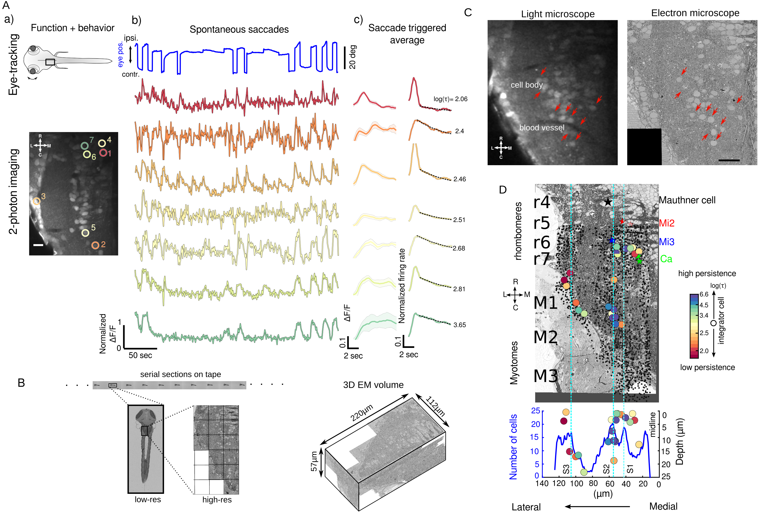

Figure 1: Functional and structural imaging of integrator neurons.

(A) (a) Top - Larval zebrafish schematic showing the region where functional imaging was performed (black box) located in the hindbrain, along with recording of eye-tracking behavior.

Bottom - A single imaging plane showing neurons loaded with calcium indicator OGB-1. Identified integrator neurons are show in colored circles. Colors reflect the level of persistence of the neuron. Scale bar 20*m*

(b) Spontaneous eye movement (top, blue line) showing saccades (sharp vertical lines) and post-saccadic fixations (horizontal lines). . Colored traces below are the changes in fluorescence from individual neurons in (a). Colors reprensent the persistance level of the neuron.

(c) Normalized fluorescence and firing rate of neurons in (a). Thick line shows the average, with shaded region showing the SEM. Dotted line is the exponential fit to determine persistence time constant, represented as *log*().

(B) Serial-sections for electron microscopy were collected on tape in an automated manner. Each section was imaged at low-resolution (b1). A region-of-interest that corresponded with the functionally imaged area was defined (black box in b1) for high-resolution imaging (b2). All such images were aligned to generate a 3D EM volume.

(C) Registration of LM volume to EM volume to locate the neurons that were involved in the behavior. Red arrows indicate the same features in both LM and EM. Scale bar 20*m*

(D) An example EM plane showing anatomical landmarks, Mauthner neuron (black star), Mi2 (red stars), Mi3 (blue stars) and Ca (green stars). Anatomical locations of all identified integrator neurons (colored circles) and all remianing cell bodies in the imaged EM volume ( ‘•’ symbol). Colors of the integrator neurons correspond to the persistence time of the neuron. Lower panel is a distribution of all neurons along the medio-lateral axis with integrator neurons overlaid. Dotted lines (cyan) are the identified somata stripes (S 1-3).

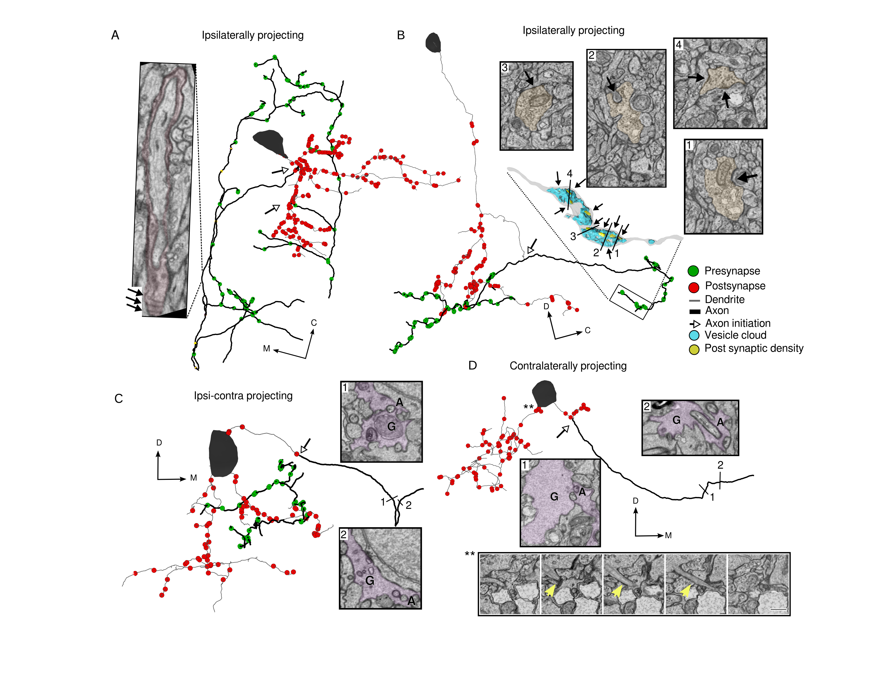

Figure 2: Ultrastructural features of Integrator neurons.

(A) Integrator neuron with ipsilaterally projecting axon (dark lines) and dendrite (light lines) with presynaptic (green circles) and postsynaptic (red circles) locations. Parts of the axon of this integrator neuron are loosely-myelinated. Insets shows axons with loose myelin (colored), arrows showing individual myelin sheaths. Open arrow heads show the location of axon initiation.

(B) Integrator neuron with ipsilateral projecting axon. Axon is studded with presynaptic sites that are clustered along neurite. Inset is a 3D reconstruction of axon termination zone with a large vesicle cloud (blue) with multiple post synaptic densities (yellow) opposed to the vesicles. Numbers correspond to EM insets showing the synapses. M - Mitochondria, V - Vesicles. Arrows show the synapses at those locations.

(C) Integrator neuron with both ipsi and contralateral projecting axon. Putative contralateral axon emerges from somata and is engulfed by glial before crossing the midline. (EM insets at numbered locations G - Glia, A - Axon) Open arrowhead shows the axons initiation site.

(D) Integrator nerons with only contralaterally projecting axon. Putative axon is engulfed by glia before crossing the midline.(EM insets at numbered locations G - Glia, A - Axon). Bottom EM panel shows primary cilium highlighted with yellow arrow. Note all the integrator somata in this volume give rise to a cilium, but it is shown for this neuron.

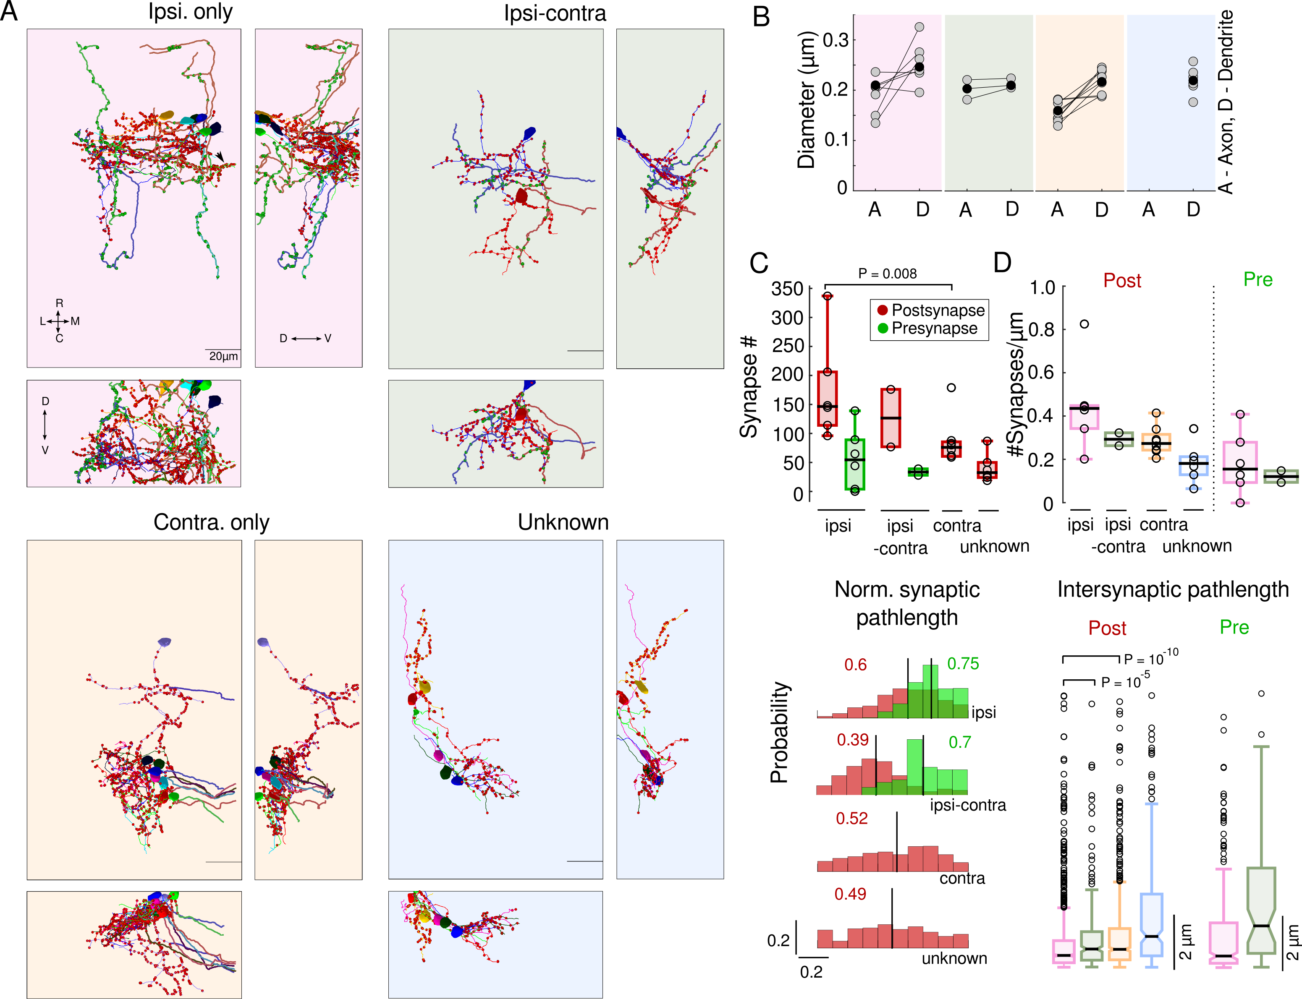

Figure 3: Integrator neurons projection patterns and synaptic distribution.

(A) Colored panels show three views of reconstructed integrator neurons, grouped according to their axonal projection patterns. Top left, 6 integrator neuron with ipsilateral projecting axons - ipsi-only group, pink background. Top right, 2 integrator neurons with ipsilaterally and putative contralateral projection – ipsi-contra, green background. Bottom left, 8 integrator neurons with midline crossing contralateral only putative-axon – contra-only, orange background. Bottom right, 6, integrator neurons with unknown axonal projection – unknown, blue background. Axons - dark line, dendrites - light lines, red circles - postsynaptic sites, green circles - presynaptic sites.

(B) Axonal and dendritic diameter of all neurons in each of the four groups. Grey dots are averages for each neuron and black dots are averages per group. A - Axon, D - Dendrite.

(C) (Top) Box plot of the number of synapses in each group. Black line is the median (significance reported as Wilcoxn rank-sum test).

(Bottom) Normalized distribution of the synaptic pathlength. Red - postsynaptic sites, green - Presynaptic sites. Black vertical lines, with adjoining colored numbers represent the means of the distribution..

(D) (Top) Box plot of the Synaptic density for each group. Black lines are the medians.

(Bottom) Box plots of the intersynaptic path length for all four groups. Notches are the 25th and 75th quantiles. Open circles are outliers (significance reported as Wilcoxn rank-sum test).

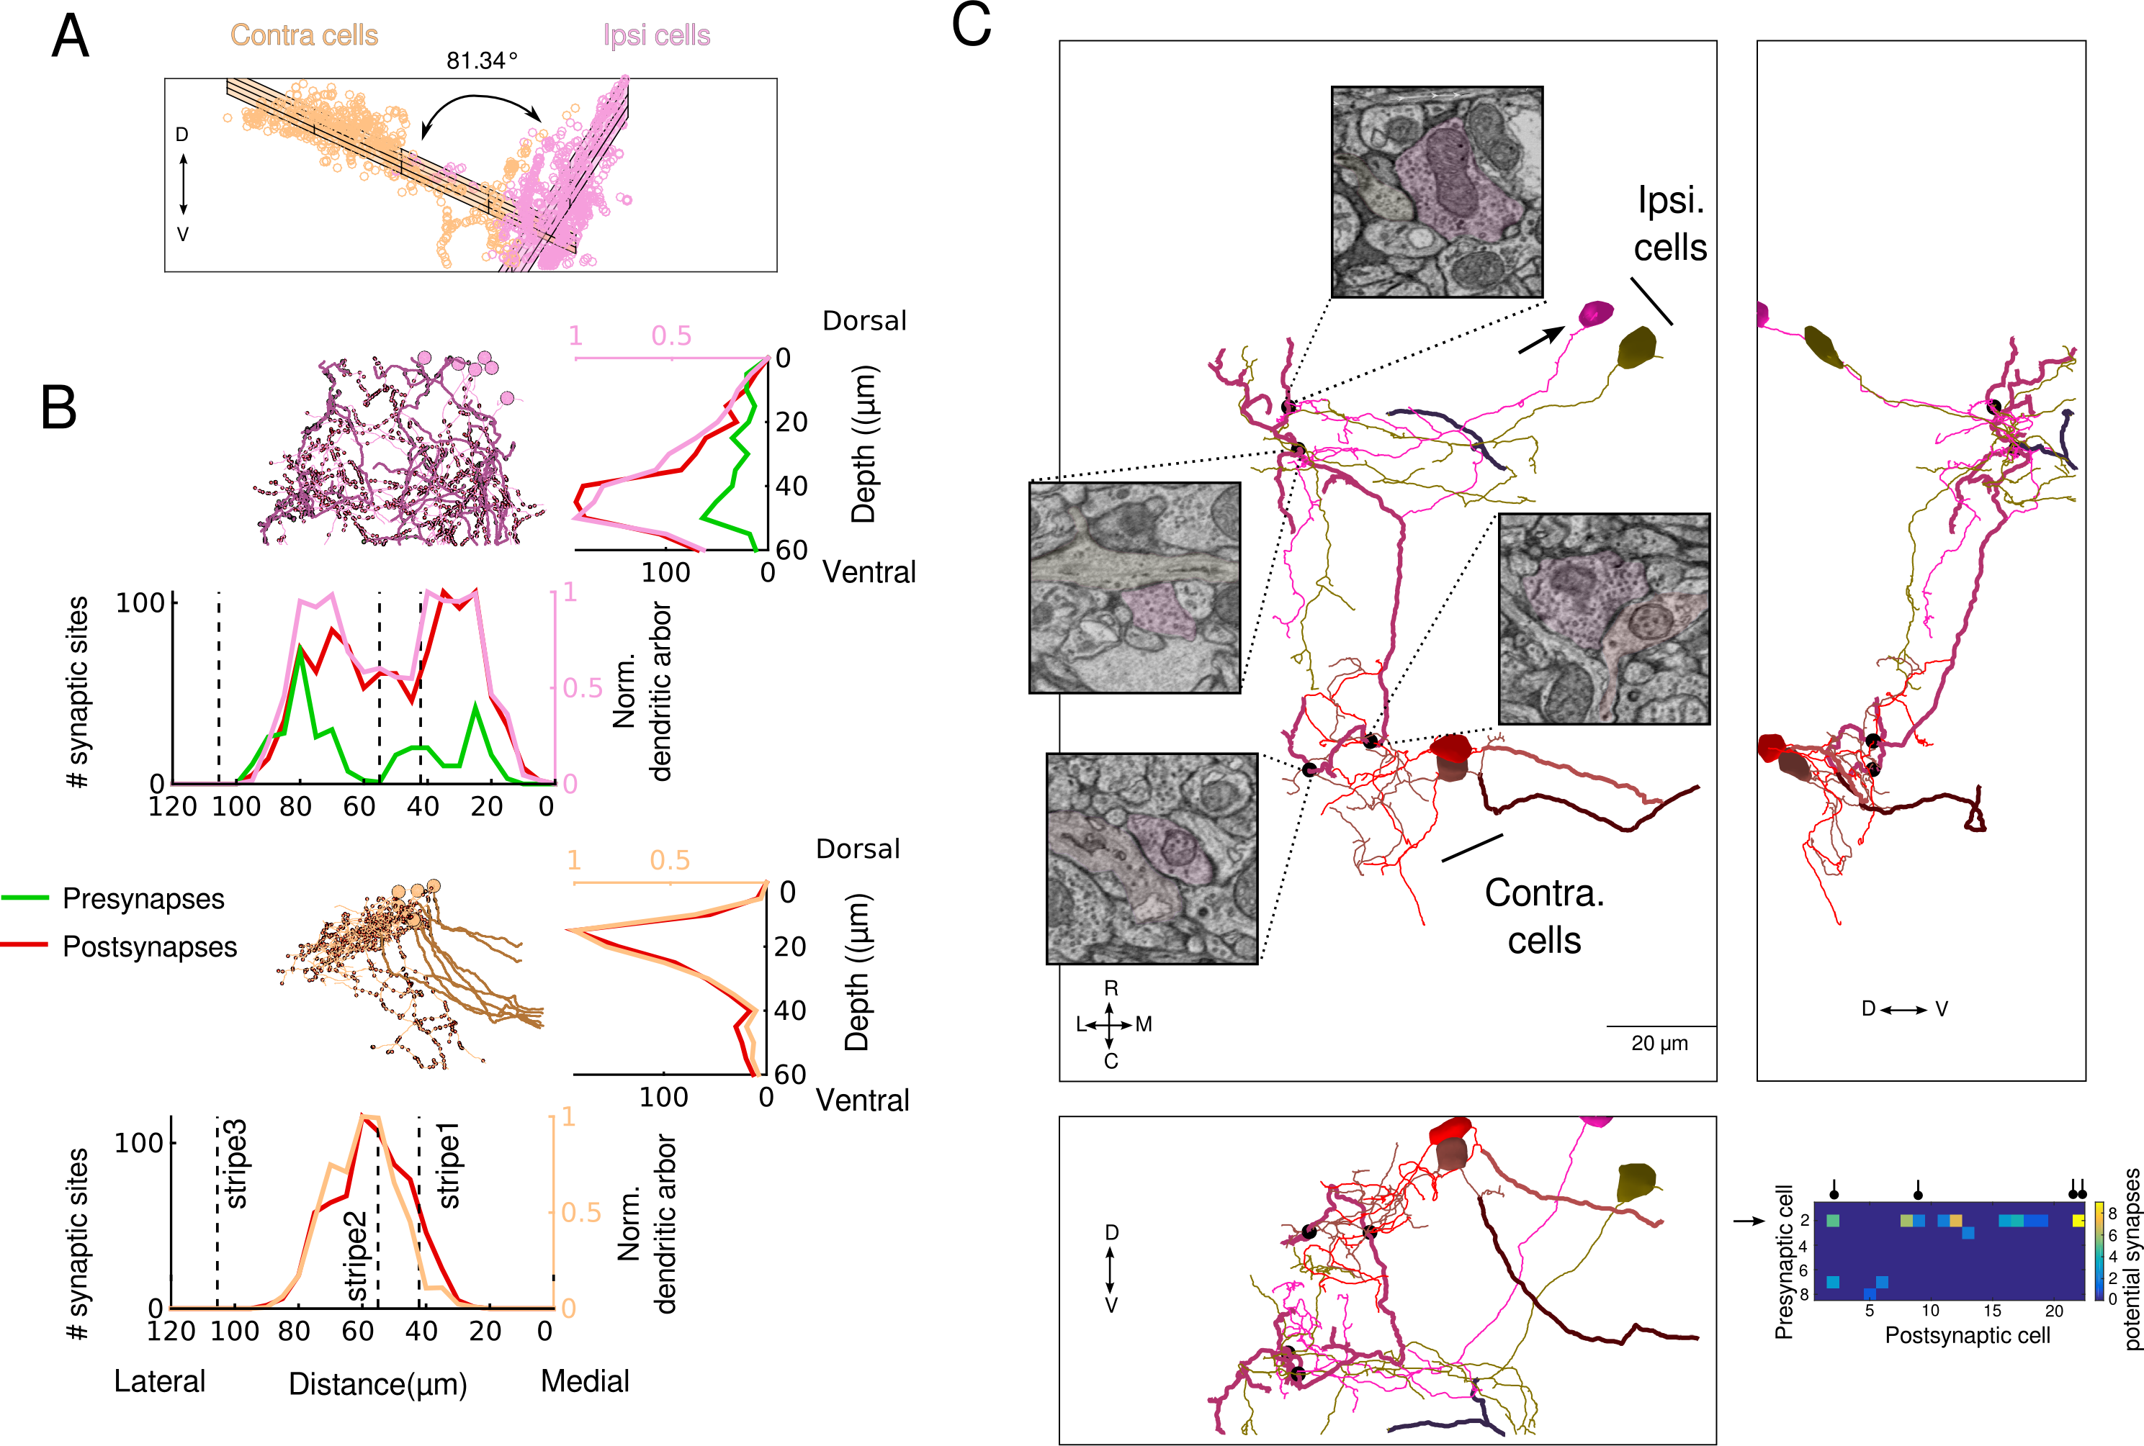

Figure 4: Integrator neurons are synaptically connected.

(A)Planar organization of ipsi (pink) and contra (orange) neuron postsynaptic sites. Grid represents the bset fit plane through the cloud of points for each group.

(B) (Top) Stratification profile of all ipsi group of neurons. Two side views show the stratification of the dendrites, presynaptic and postsynaptic sites along the dorso-ventral and medio-lateral axis. Dotted line represent the location of the somatic peaks that was computed in Figure 1.

(Bottom) Stratification proflie of all contra group of neurons.

(C) Three views of synaptically connected integrator neurons. All synapses were from one neuron (magenta, arrow) in ipsi-only group onto one other neuron from ipsi-only group (olive). One synapse each from ipsi-only group neuron (magenta) onto two contra-only neurons (red and brown). Black dots represent the location of the synapses, with insets showing the electron micrograph at the respective location. In all electron micrographs.

(inset) Potential synapses that are <1:*m* from each other. Presynaptic cell# 2 (arrow), is the same neuron in (A, magenta) that makes maximum number of potential synapses onto other neurons and makes the real synapses shown in (A). The real synapses are represented by the black circle in the header.